Pennsylvania
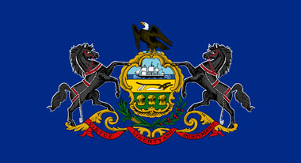 Pennsylvania flag
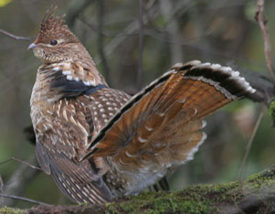 State bird: Ruffed Grouse
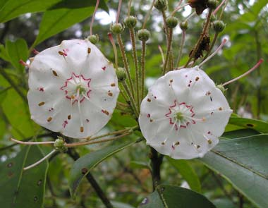 State flower: Mountain Laurel

State Motto: Virtue, Liberty, & Independence

