New Jersey
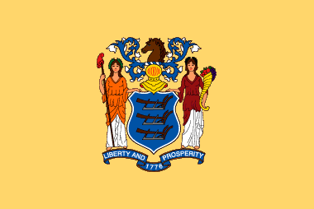 New Jersey flag
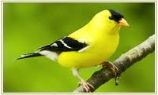 State bird: American goldfinch

State flower: Violet

State Motto: Liberty and Prosperity

