Michigan
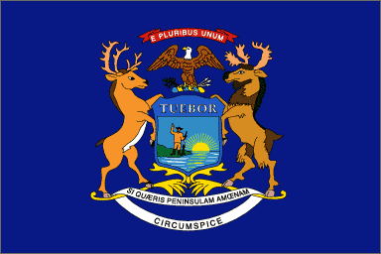 Michigan flag
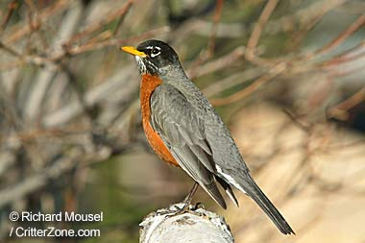 State bird: American robin
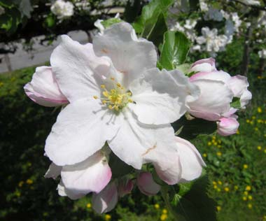 State flower: Apple Blossom

State Motto: "If you seek a pleasant peninsula, look about you."

