Hungary

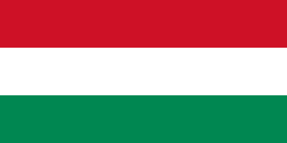 Hungary flag

 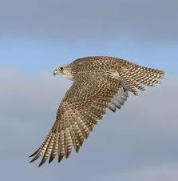National bird: Turul

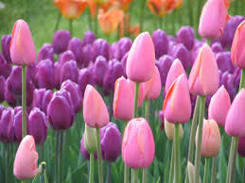 National flower: Tulip

|  |  |
| --- | --- |
| **National Motto:** | Kingdom of Mary, the Patron of Hungary |